1. **Create one IAM user and assign ec2, s3 full access role.**

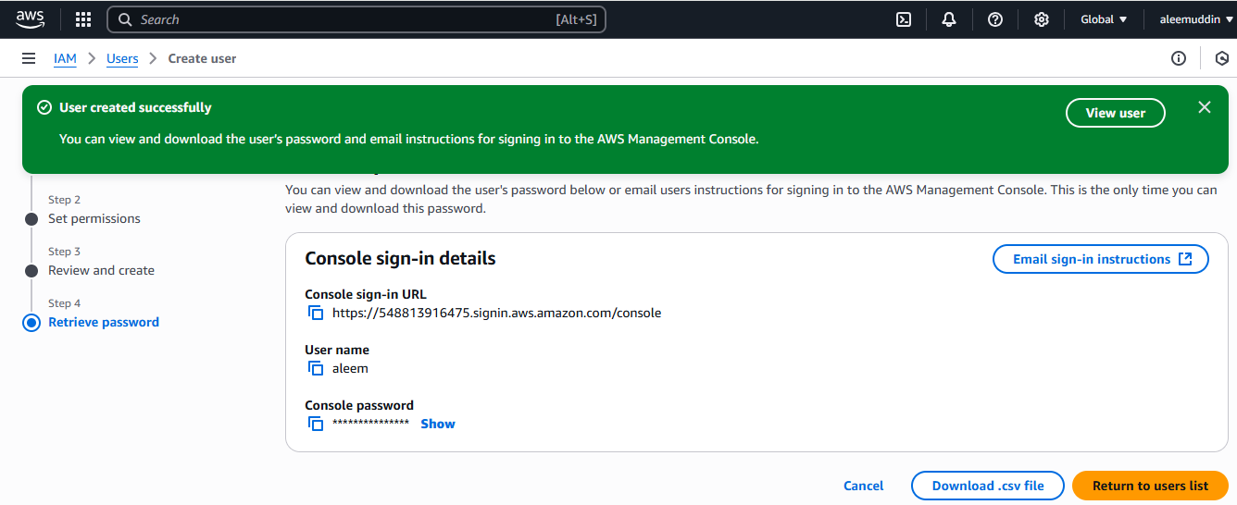

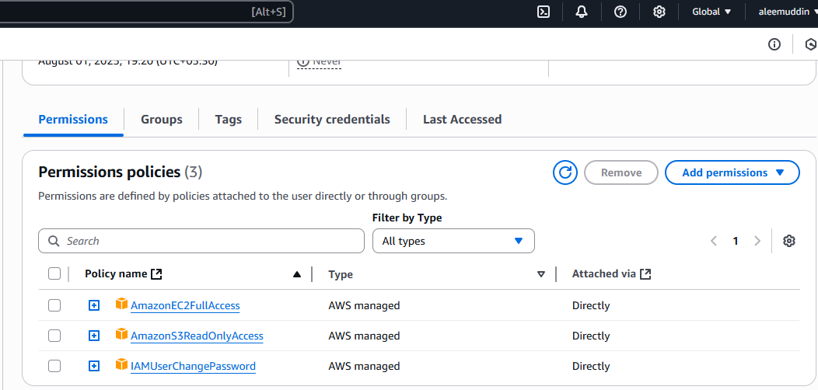

1. **Create one Group in IAM and Assign Read access for ec2.**

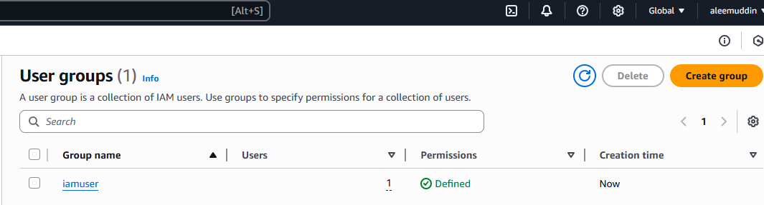

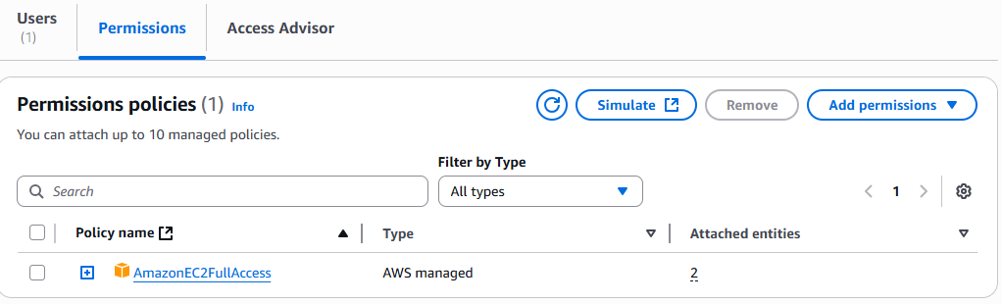

1. **Create a new user with name Devops and add to the group created in task2.**

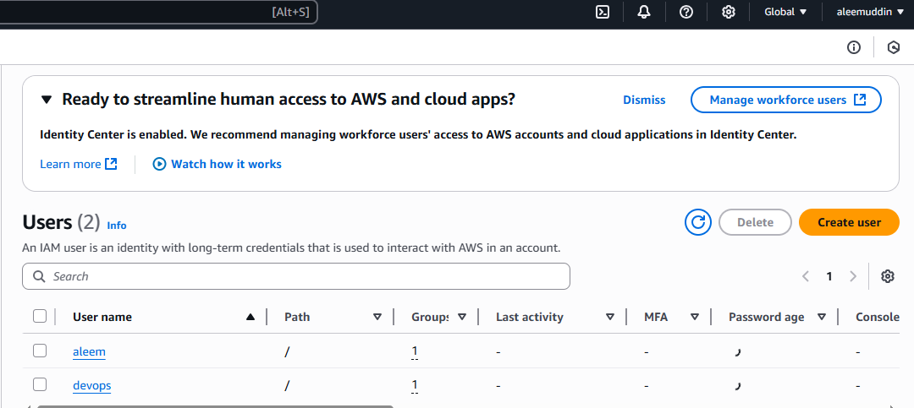

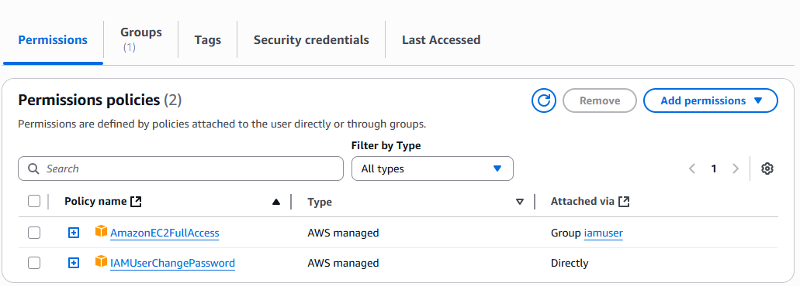

1. **Write a bash script to create an IAM user with VPC full access.**

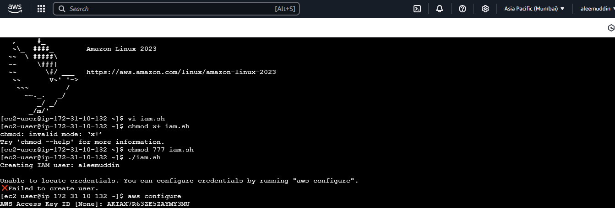

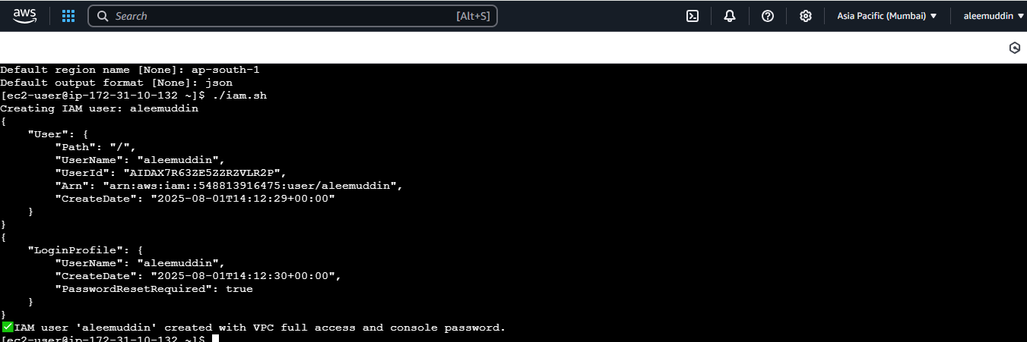

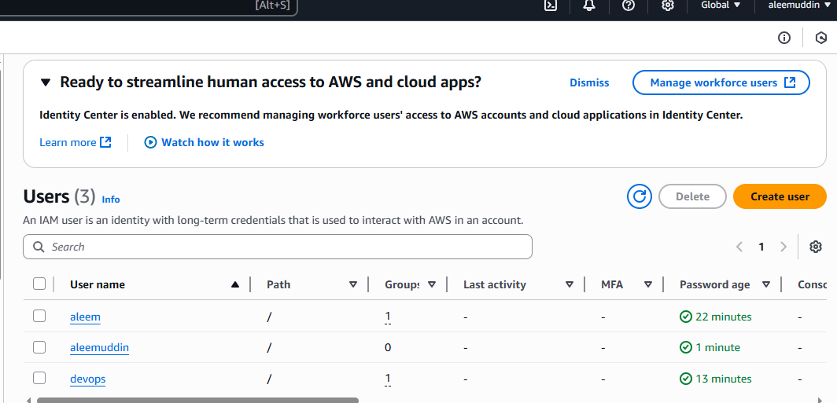

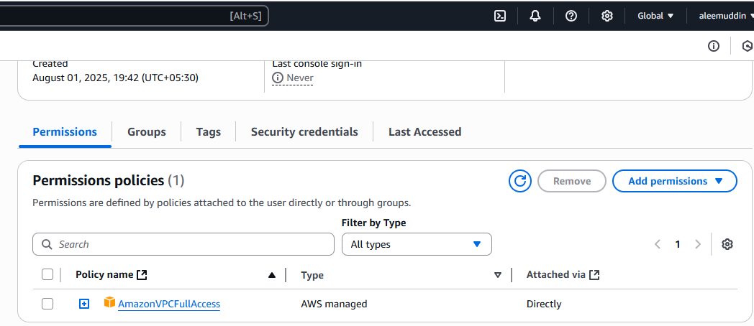

1. **Create an IAM policy to access ec2 for a specific user in specific regions only.**

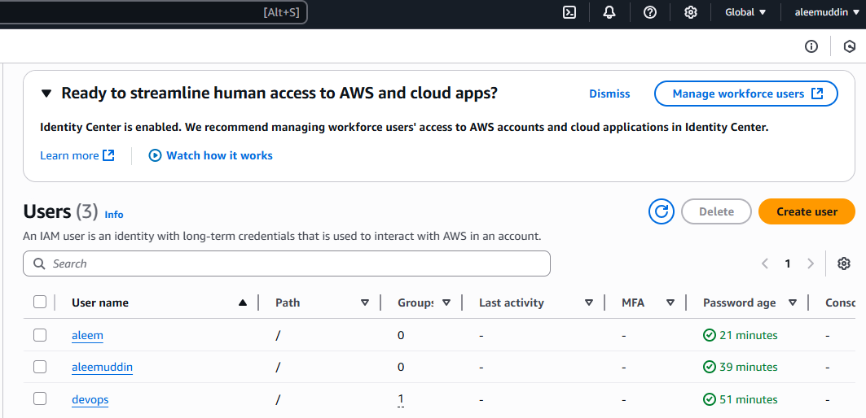

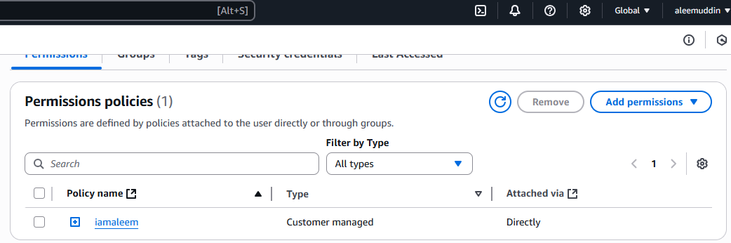

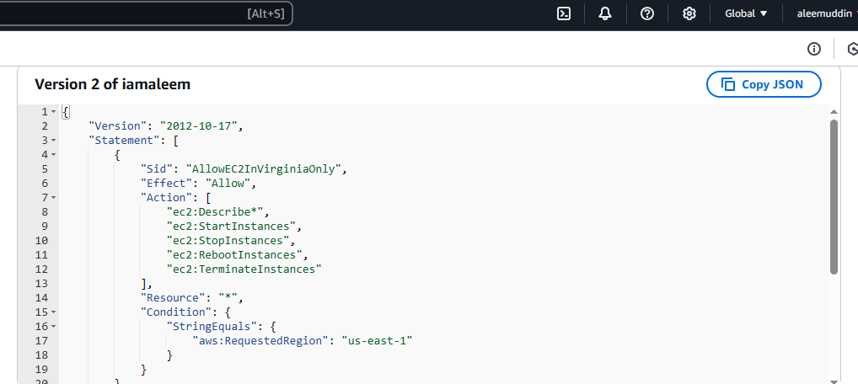

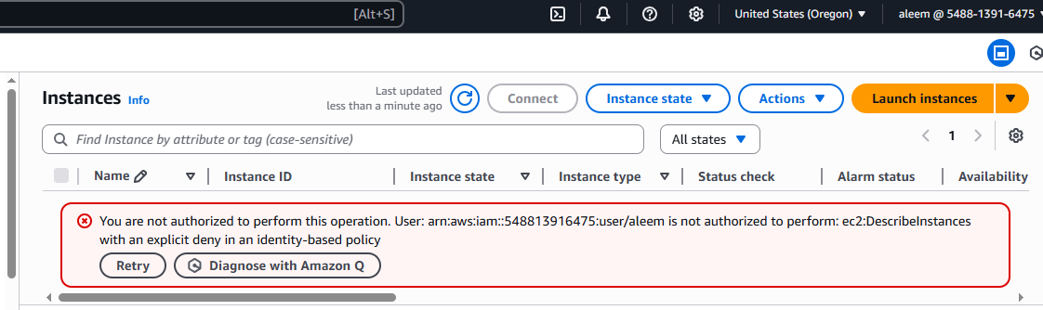

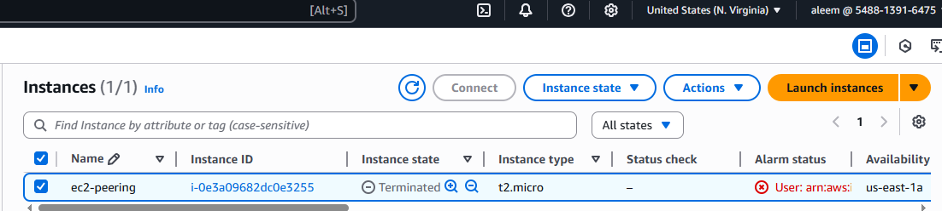

**6) We have two accounts Account A and Account B, Account A user should access s3 bucket in Account B.**

**(Collaborate with team member and execute this. Mostly asked in every interview)**

**Account-A Details**

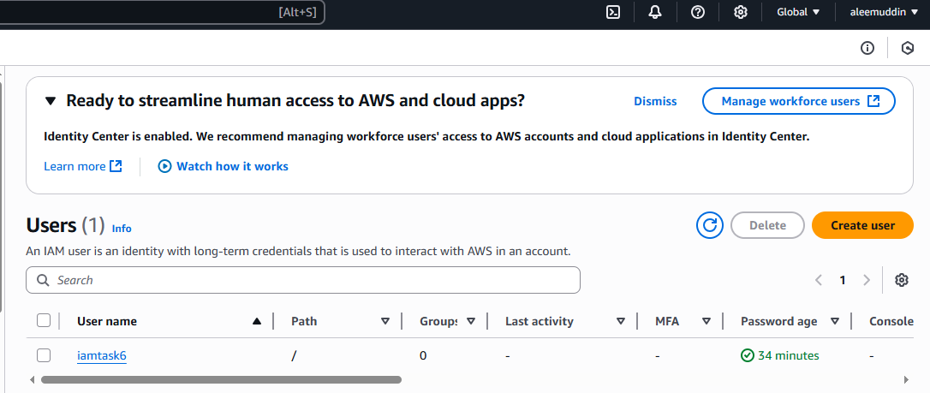

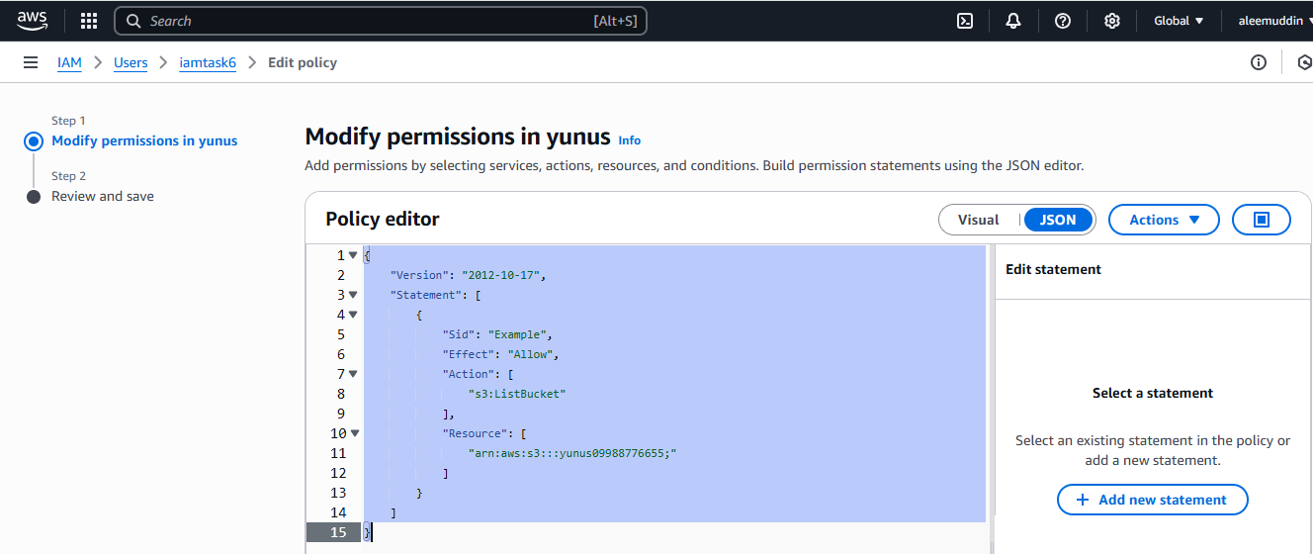

**{**

**"Version": "2012-10-17",**

**"Statement": [**

**{**

**"Sid": "Example",**

**"Effect": "Allow",**

**"Action": [**

**"s3:ListBucket"**

**],**

**"Resource": [**

**"arn:aws:s3:::yunus09988776655;"**

**]**

**}**

**]**

**}**

**Account-B Details**

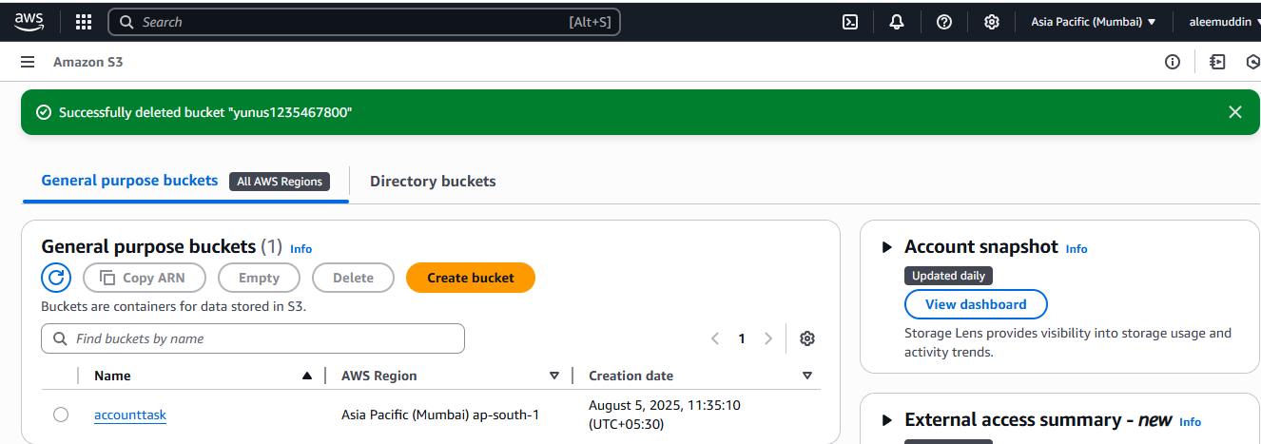

**{**

**"Version": "2012-10-17",**

**"Statement": [**

**{**

**"Sid": "Example permissions",**

**"Effect": "Allow",**

**"Principal": {**

**"AWS": "arn:aws:iam::450119683904:root"**

**},**

**"Action": [**

**"s3:GetLifecycleConfiguration",**

**"s3:ListBucket"**

**],**

**"Resource": "arn:aws:s3:::accounttask"**

**}**

**]**

**}**

**Result:**

